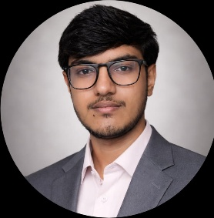
MOHAMMED DAIYAN
Contact Info
• +91 6363309248 • daiyan63633@email.com •LinkedIn • GitHub

CAREER OBJECTIVE
Motivated Computer Science under-graduate seeking an entry-level software development position where I can apply my programming skills, problem-solving abilities, and passion for technology to contribute to impactful projects while growing as a professional.

EDUCATION
Bachelor of Technology in Computer Science & Engineering (2024-2027)
National Institute of Engineering, Mysore
CGPA: 8.19 / 10
Diploma in Computer Science and Engineering (2021-2024)
D. Dharmaprakasha Banumaiah’s Polytechnic, Mysore
Percentage: 85.80%
SSLC (X) (2021)
Regional International School, Mysore
Percentage: 85.12%
TECHNICAL SKILLS
Languages: Java, Python, C, JavaScript, SQL
Frontend: HTML5, CSS, React.js, Bootstrap
Backend: Spring Boot, Node.js, REST APIs
Databases: MySQL, MongoDB
Tools & Others: GitHub, VS Code, Eclipse, Antigravity

PROJECTS
PolyArguMinds
AI-Powered Discussion Platform
Tech Stack: React · Spring Boot · MySQL
• Built a full-stack web platform enabling structured debates with AI-generated arguments
• Implemented user authentication with JWT, role-based access control, and REST APIs
• Deployed frontend on Vercel and backend on Render with Docker containerization
AI Resume Analyzer
Tech Stack: Python · NLP · Flask
• Developed an NLP-based system that parses resumes and matches them against job descriptions
• Used keyword extraction, TF-IDF scoring, and cosine similarity for intelligent matching
• Built a Flask web interface for uploading resumes and viewing analysis results
Digital Library Management System
Tech Stack: Spring Boot · MySQL · REST
• Created a backend system for managing library catalog, user accounts, and book borrowing workflow
• Implemented RBAC with Spring Security for admin and member roles

LANGUAGES
Proficient: Kannada, Hindi, Urdu, English
ACHIEVEMENTS
• Tech Tatva Hackathon 2025 — Finalist

